Sundial in Blender
Assunta DeSanto
Professor: Dr. Jeyaprakash Chelladurai
COMP430: Interactive Computer Graphics
Project Report
Department of Applied Computer Science
Lock Haven University of Pennsylvania
Lock Haven, PA, USA
Fall 2018

1. Introduction

1.1 Background
Before the invention of the modern clock, which relies on quartz and mechanics to accurately measure time, many civilizations used sundials to determine the time of the day. There are many different types and styles of sundials, and the angle of the time markers differs based on where the user is geographically, as the angle that the sun hits the earth changes based on how close one is to the equator.

1.2 History of Sundials
Historically, the first shadow clocks were found in ancient Babylon. From there, they can be found in ancient Russia, China, and the Middle East. The Bible mentions a sun dial in Isaiah, and that is believed to be the earliest written account of time telling. However, the model was perfected by the ancient Greeks, because of their understanding of geometry and the cosmos.
Sundials across cultures varied, not only because of materials used and cultural style, but also because the light from the sun would hit the pointer at a different angle. Moreover, there are multiple different styles of sundials based on preference for display.

1.3 Contribution
The purpose of this project is to create an accurate model of a sundial with a spot light. Moving the spot light in a path similar to the sun’s path will show the passing of time.

1.4 Organization
The rest of this report is organized as follows: Section 2 gives a formal description of the unit circle and why it is essential to creating an accurate model. Section 3 describes the implementation. Section 4 concludes the report and discusses future work.

2 Formal Description
Because this representation of a sun dial is not dependent on the actual angle of the sun, the need to vary the difference between angles was not a factor. Therefore, without much variation, the model uses the standard unit circle, without drawing all of the points on the circle, since nearly half of them do not correlate to a time of day, but rather to a time of night, where a sundial would not help tell time.

3 Implementation
To begin the project, I needed to call my imports.
import bpy
import math
import mathutils

Next, I removed all objects from the scene, so that I had a blank canvas to work with.
bpy.ops.object.select_all(action ='SELECT')
bpy.ops.object.delete()

Then, I set my variables. I needed to specify the number of points in the unit circle that I would need. 24 is the number of hours in a day, and even though some of them will not be drawn, (because they are dark hours, it is necessary to count all 24 here to form a full circle.
Additionally, I set the radius to 1.
H=24
rad=1

In my loop, I specify that I only want 13 of the hour markers to be drawn. There is certainly a more thoughtful way of doing this, rather than using the magic number H-11, but in the interest of time, I formulated it so that it would draw the semi-circle correctly. As for what is in the loop, it is little different than the standard unit circle – the size, and radius of the markers are the only notable differences. The markers for my layout are equidistant.
for i in range(H-11):
angle = i * math.pi*2/H
x = rad*math.cos(angle)
y = rad*math.sin(angle)
z = 0
bpy.ops.mesh.primitive_cube_add(
radius = 0.05,
location = [x,y,z])

The cone is the sundial node. This is what will create the shadows unto the markers. It is set directly in the middle of the markers. The bottom radius was manipulated to make it smaller.
bpy.ops.mesh.primitive_cone_add(location = (0,-1,0.95), radius1 = 0.4)

I, then, add a plane to see the shadows better, and scale it appropriately to cover all the parts of the sundial model.
bpy.ops.mesh.primitive_plane_add(location = (0,0,-0.05))
bpy.ops.transform.resize(value = (1.5,1.5,1.5))

Next, a spot lamp is placed at the location where it would be around noon. I set the lamp to a 45 degree angle so that it creates a nice shadow on my sundial node.
bpy.ops.object.lamp_add(type='SPOT',radius=1.0,location=(0,-2,3),rotation = (0.7,0,0))

Finally, I add a camera, so that I can render the image and see the shadows.
bpy.ops.object.camera_add(location = (0,0,8))

4 Conclusions

4.1 Results
By moving the spot lamp along the x axis, I can manipulate the time.
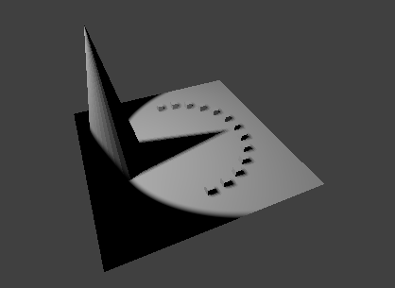
Here is a picture of 12:00 pm.

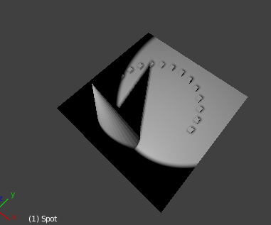
Here is a picture of 9:00 am.

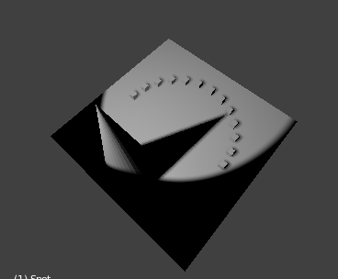
Here is a picture of 2:00 pm.

4.2 Future Work
In the future this project can be adapted to use line motion graphics and move the sun in a realistic way. It can also be adapted to different regions of the world, by changing the placement of the markers and the sundial node, as well as the angle of the spot lamp.

5 References
“History of Sundials.” Wikipedia, Wikimedia Foundation, 29 Nov. 2018,
en.wikipedia.org/wiki/History_of_sundials.

